**ROAD POTHOLE PREDICTION USING CNN**

# Dr.M.Rajendiran Sriram S

Professor Department Of Computer Science And Engineering

Department Of Computer Science And Engineering Panimalar Engineering College

Panimalar Engineering College sriramsrinivasan297@gmail.com

# Shanmugsundaram V Siddarthan E

Department Of Computer Science And Engineering Department Of Computer Science And Engineering

Panimalar Engineering College Panimalar Engineering College

shanmugamsms123@gmail.com siddarthmsdian@gmail.com

**ABSTRACT**

***Pothole is one of the major types of defects frequently found on the road whose assessment is necessary to process. It is one of the important reason of accidents on the road along with the wear and tear of vehicles. Road defects assessment is to be done through defects data collection and processing of this collected data. Currently, using various types of imaging systems data collection is near about becomes automated but an assessment of defects from collected data is still manual. Manual classification and evaluation of potholes are expensive, labour-intensive, time-consuming and thus slows down the overall road maintenance process. This paper describe a method for classification and detection of the potholes on road images using convolutional neural networks which are deep learning algorithms. In the proposed system we used convolutional neural networks based approach with pre-trained models to classify given input images into a pothole and non-pothole categories. The method was implemented in python using OpenCV library under windows and colab environment, trained on 722 and tested on 116 raw images. The results are evaluated and compared for convolutional neural networks and various seven pre-trained models through accuracy, precision and recall metrics. The results show that pre-trained models InseptionResNetV2 and DenseNet201 can detect potholes on road images with reasonably good accuracy of 89.66%.***

***Keywords:******convolution neural networks , deep learning***

***,pothole detection, , pre-trained models***

# I. INTRODUCTION

The first step toward prompt repair of the road surface is to get known the condition of the road in terms of defects. The most common defect on road surfaces are potholes, bowl-shaped holes of various sizes in the pavement surface [1]. On road surface potholes are formed by a variety of reasons namely wear and tear of the road, age of the road, heavy rainfall, materials responsiveness to climate change, bad construction material used and external factors such as poor drain and quality construction management. Recently,

damaged roads surface with potholes as shown in Fig. 1,

are increasing in India, and in Mumbai and thus complaints related to potholes are also increasing. Road with good condition always contributes a major portion to the country’s economy.

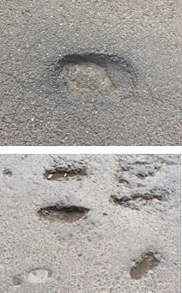

**Fig. 1. Example of Potholes.**

Effective maintenance of road surface is one of the major problems in developing countries becomes a great challenge for road maintenance authorities

The study of automatic distress analysis systems have obtained great attention in the past decades and many automatic distress analysis systems have been proposed. Road damages are important information for evaluating the road condition and conducting the necessary road maintenance activities. Conventional human visual pavement distress detection method is time-consuming, very expensive, labor-intensive and slows down the road maintenance management. Road surfaces get deteriorate over the age and thus they require corrective measures to restore safety and ride-ability. The need for fast accurate non-subjective inspection for road distresses is becoming important. The automated system is necessary to predict future deterioration rates and budgets.Pothole detection and estimation is one of the important tasks for the proper planning of reparation and rehabilitation of the road surface. At present, Road maintenance companies need many working hours for a

rough estimation of damage on the road.

The cost-effectiveness of the overall patching operation is affected by material, labor, and equipment costs. The key to decision making for future reconstruction is the estimation of damage from the collected information.

In this paper, we present a convolutional neural network based approach for classifying and detecting potholes from road images. We used raw road-pothole and normal images instead of requiring the extraction of features from the images. The methodology has been implemented on images from internet resource from Kaggle and from manually collected images with a variety of potholes in terms of shape and size and non-defect road images from various areas of Mumbai and nearby highways. A total of 838 images are used. Various pertained models ResNet50, ResNet152,

ResNet50V2, ResNet152V2, InceptionV3,

InceptionResNetV2, and DenseNet201 are used to compare the result with self-built CNN architecture. We used 5 convolution layers in CNN. We found the accuracy of 80.17% with the CNN model. Among seven pre-trained models, from InseptionResNetV2 and DenseNet201 models we achieved good accuracy of 89.66%. Based on the experimentation we found that the proposed method can successfully detect potholes with good accuracy.

# II. RELATED WORK

From the literature survey carried out, there are different methods for pothole detection namely Vibration-based methods, 3D reconstruction-based methods and Vision-based methods. Vibration-based methods are low cost but cannot be used at bridge expansion joints and also cannot detect pothole which lie in the centre of a lane; 3D reconstruction-based methods require sophisticated, high cost equipment and stereo vision methods need a high computational effort to reconstruct pavement surface through the procedure of matching feature points between two views; vision-based methods accuracy is algorithm dependent and very much depends on input images captured which are based on lighting conditions and environmental factors such as time of the day, rainfall, cloud cover etc. Koch and Brilakis 2011, Kim and Ryu 2014 and H. Bello-Salau 2014 [2]-[4] describes the detail surveys on methods for pothole detection. Convolutional neural network for pothole detection system using thermal imaging has been proposed by Aparna et al. [5]. Authors compared results with self-built CNN architecture by changing some parameters twice and achieved test accuracy of 64.42% and 73.06%. Authors also tried different pre-trained ResNet model. Authors obtained results on image size 224 using ResNet101 pre-trained model and achieved validation accuracy of 97.08%.

A. Kwang et al. [6] detected potholes by using smartphone camera and image classification method based on the deep convolutional neural network models and obtained the classification accuracy rate of 97% using coloured images and 97.5% using grayscale images.

S. Hyunwoo et al. (2018) [7] proposed a way to implement detection of pothole using a smartphone, and classification is performed using Transfer Learning. 70% data (70 instances) is used for training and 30 % data (30 instances) is used for testing. Proposed method recognized correctly all of the instances showing 100% of classification rate.

K. Lim and J.Kwon (2018) [8] proposed a deep convolutional neural network (CNN) based on YOLOv2 approach. In this method, the author discussed a significant increase in performance over YOLOv2 from 60.14% to 82.43% average precision. Proposed F2-Anchor and Den-F2-Anchor models achieved better results.

A. Akagic et al. (2017) [9] proposed an unsupervised vision-based method for pothole detection based on RGB color space image segmentation. Method uses manipulation of B component in RGB space and is designed for use under daytime fair weather conditions. The method was tested on 80 different pothole images and they achieved an accuracy of 82%.

S. Ryu et al. (2015) [10] have designed a pothole detection system which includes optical device mounted on a vehicle with functions such as collecting and storing data of potholes, communicating by Wi-Fi, and gathering location information by GPS and a pothole detection algorithm with classification accuracy rate of 73.5%.

Lin and Liu (2010) [11] proposed a method which uses the nonlinear support vector machine to detect pothole. In this approach potholes are recognized by using texture measure as a feature. Partial differential equation PDE model is used for image segmentation and nonlinear SVM tool for classification. The proposed model by using the training from the non-linear SVM, achieves satisfactory result for the pothole recognition. Some complicated cases like potholes flooded with mud are not correctly identified. Also intact area of pothole defect is not detected.

# III. PROPOSED MTHODOLOGY

The aim of this study is to develop a system to classify between potholes and non-potholes (normal) of road images. Convolutional neural networks are deep learning algorithms that are useful for the classification and analysis of images. We used a convolutional neural network (CNN) to train the input images of pothole and non-pothole (normal) collected manually and images available on internet resource from kaggle. The various pre-trained neural network models like ResNet50, ResNet152, ResNet50V2, ResNet152V2, InceptionV3, InceptionResNetV2 and DenseNet201 are experimented for comparison of results. Fig. 2, represents the methodology for the proposed work.

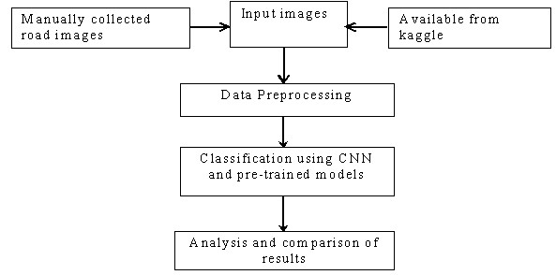

# Fig. 2. Methodology used for pothole classification and detection

**A. Classification of images with feature extraction using various classifiers:**

A Convolutional Neural Network is a Deep Learning algorithm which takes in an input image, assign importance (learnable weights and biases) to various aspects/objects in the image and able to classify one from the other.

Input images are fed to model as potholes and non-potholes of the road surface and model is trained. The convolutional neural network and pre-trained model gives image classification in two categories pothole and non-pothole.

***The architecture of CNN model used for experimentation:***

The model consists of 5 Convolution layers with ReLU activation function. Following parameters were used for the experimentation. Batch size = 32

Epoch = 25

Total images = 838

Train: validation: split = 722:116

Image size = 224 x 224

Optimizer: Adam

Total Categories = 2

Loss function = Categorical cross entropy Weights: Random initialized

***Pre-trained residual network models:***

In this proposed system, we also used seven pre-trained models, with weights pre-trained on ImageNet.

We carried out experimentation using these seven pre-trained models for image classification into pothole and non-pothole categories and compared the overall results. The used seven pre-trained models were ResNet50, ResNet152, ResNet50V2, ResNet152V2, InceptionV3,

InceptionResNetV2, and DenseNet201. Among these seven pre-trained models five models ResNet50, ResNet152, ResNet50V2, ResNet152V2 and DenseNet201 accepts an input image size of 224 x 224. And other two pre-trained models Inception V3 and Inception-ResNetV2 model accepts image input size of 299 x 299.

# IV. EXPERIMENTS AND RESULTS A. Implementation

The performance of the proposed method was tested on a desktop PC (Intel (R) Core(TM) i5-6400 CPU, 2.70 GHz, 8 GB RAM) in python with OpenCV library under a windows and colab environment.

# B. Data Collection

The database comprised with 838 images, collected from the local road of the city of Mumbai, nearby highways and internet resource kaggle. The images (manually) collected in varying lighting conditions and are characterized by a high variety of potholes in terms of shapes and sizes. Total dataset consist of 838 raw images without cropping. Training was carried out on 722 images and validation carried out on 116 images. Fig. 3, shows few sample images from dataset used.

# C. Data Pre-processing

For CNN model image size used is 224 x 224. For ResNet50, ResNet152, ResNet50V2, ResNet152V2, and DenseNet201 models default size is 224 x 224, so we used the same default size. For InceptionV3 and InceptionResNetV2 models default size is 299 x 299, so we used the required default size.

# D. Performance evaluation

Performance of the proposed method was measured using three metric: precision, recall and accuracy. Precision is related to the exactness and is expressed by Eq. (1); recall means to the detection completeness and is expressed by Eq. (2); and accuracy means to the average correctness of a classification process is expressed by Eq. (3).In the equations, true positives (TP, correctly detected potholes), false positives (FP, wrongly detected potholes), true negatives (TN, correctly detected as non-potholes), and false negatives (FN, wrongly detected as non-potholes).

TP

Precision = ---------- (1)

TP + FP

TP

Recall = ----------- (2)

TP + FN

TP + TN

Accuracy = -------------------------- (3)

TP + FP + TN + FN

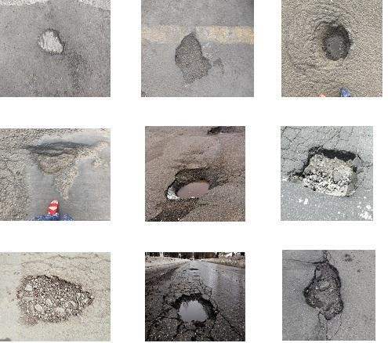

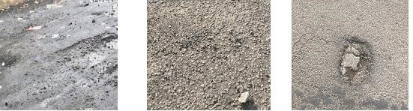

**Fig. 3. Few Samples from dataset.**

***D1. Results using CNN model:***

We tested CNN model, Fig. 4, presents CNN results graphically; Fig. 4(a) shows model accuracy plot; Fig. 4(b) shows confusion matrix. It is observed from results that average training accuracy of CNN with 25 epoch reaches to 97.65% and average validation accuracy was 80.17%. Training loss is reduced but validation loss is on still higher side.

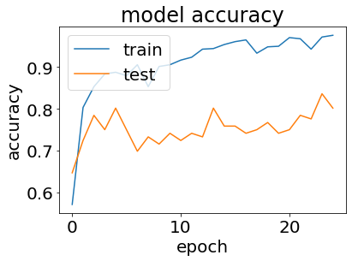

(a)

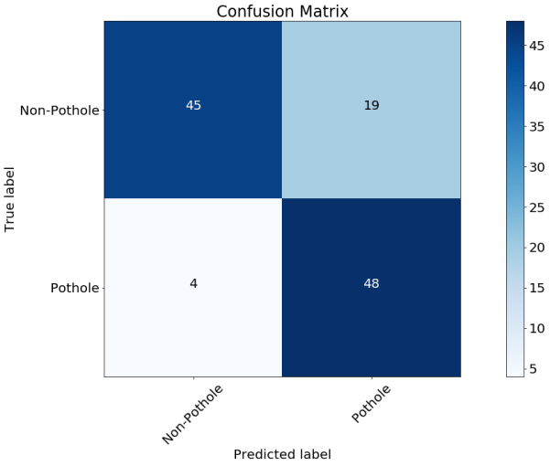

(b)

# Fig. 4. Results of CNN Model

(a) accuracy V/S epoch; (b) confusion matrix.

***D2. Results from seven pre-trained models :*** Experimentation carried out with seven pre-trained models namely ResNet50, ResNet152, ResNet50V2, ResNet152V2, InceptionV3, InceptionResNetV2 and DenseNet201 with 25 epochs.

Fig. 5 represents ResNet50 results. Fig.5(a) shows model accuracy plot; Fig. 5(b) shows confusion matrix with average training accuracy of 100 % and average validation (test) accuracy of 85.34 %.

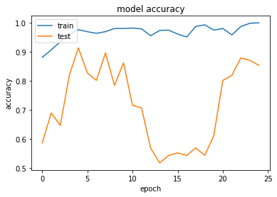

(a)

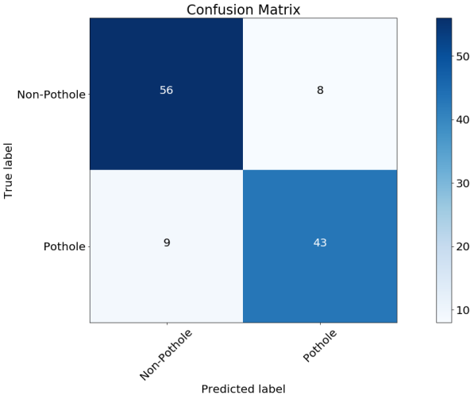

# (b) Fig. 5. Results of ResNet50 Model

1. accuracy V/S epoch; (b) confusion matrix. Fig. 6 represents ResNet152 model results. Fig. 6(a) shows model accuracy plot; Fig. 6(b) shows confusion matrix. With ResNet152 model we achieved training accuracy of 95.84% and validation (test) accuracy 84.48%.

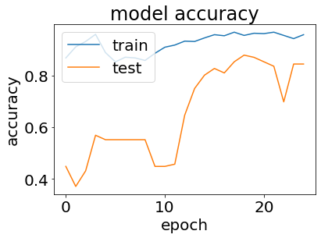

(a)

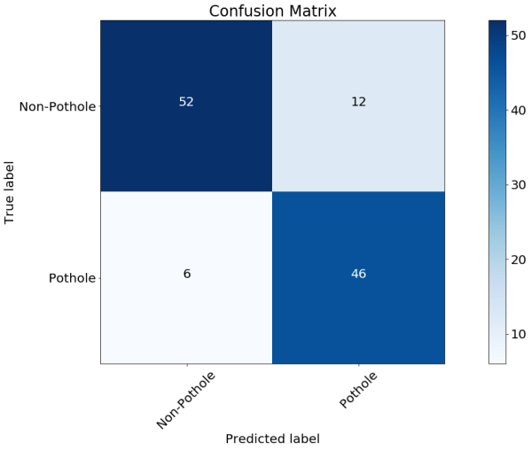

1. **Fig. 6. Results of ResNet152 Model** (a) accuracy V/S epoch; (b) confusion matrix.

Fig. 7 represents ResNet50V2 results. Fig. 7 (a) shows model accuracy plot; Fig. 7(b) shows confusion matrix. With ResNet50V2 model we achieved training accuracy of 99.31% and validation accuracy 82.76 %.

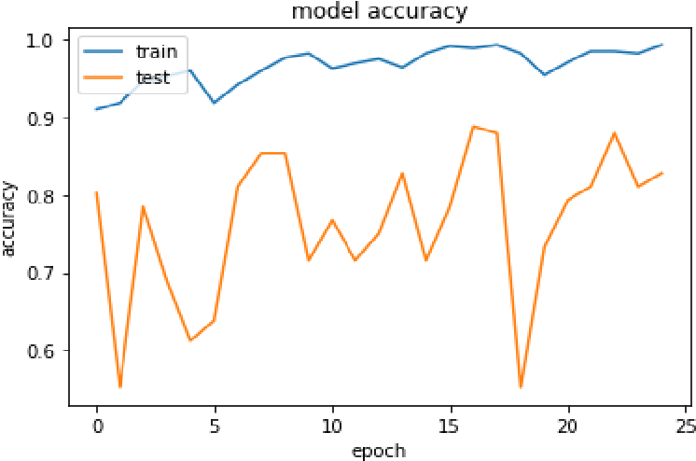

(a)

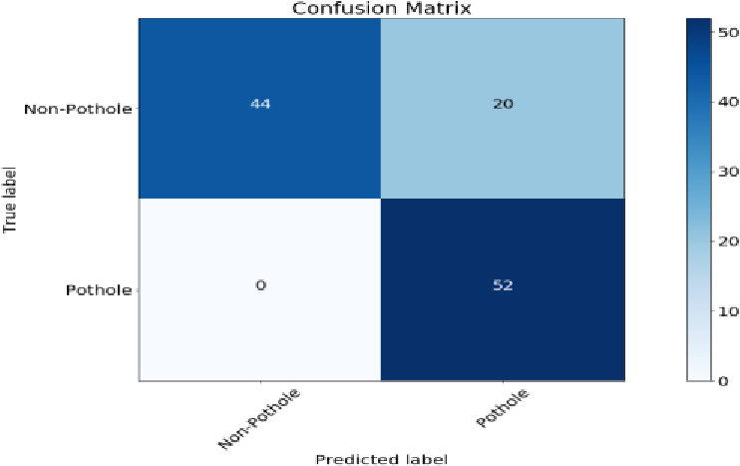

(b)

# Fig. 7. Results of ALEXNET Model

(a) accuracy V/S epoch; (b) confusion matrix.

Fig. 8 represents ResNet152V2 model results. Fig. 8(a) shows model accuracy plot; Fig. 8(b) shows confusion matrix. With ResNet152V2 model we achieved training accuracy of 92.38% and validation accuracy of 79.31%.

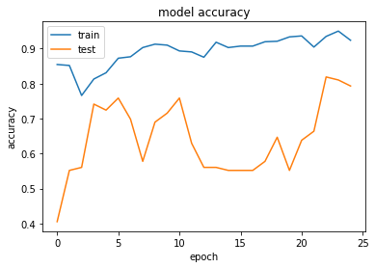

# (a)

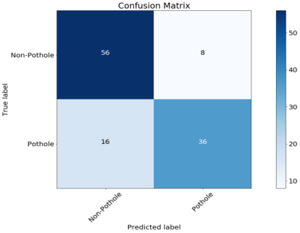

# (b) Fig. 8. Results of LENET Model

(a) accuracy V/S epoch; (b) confusion matrix.

**Fig. 9 represents InceptionV3 model results. Fig. 9(a) shows model accuracy plot; Fig. 9(b) shows confusion matrix. With InceptionV3 model we achieved training accuracy of 98.06% and validation accuracy of 85.34%.**

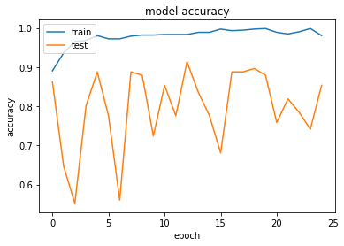

# (a)

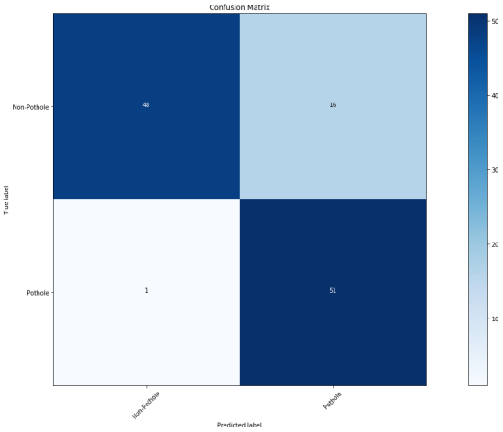

(b)

# Fig. 9. Results of InceptionV3 Model

(a) accuracy V/S epoch; (b) confusion matrix.

Fig. 10 represents InseptionResNetV2 model results. Fig. 10(a) shows model accuracy plot; Fig. 10(b) shows confusion matrix. With InseptionResNetV2 model we achieved training accuracy of 99.58% and validation accuracy of 89.66 %

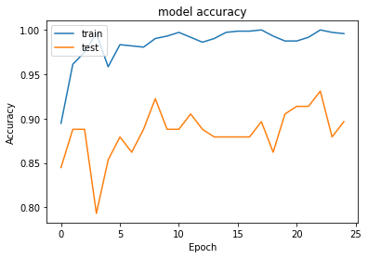

(a)

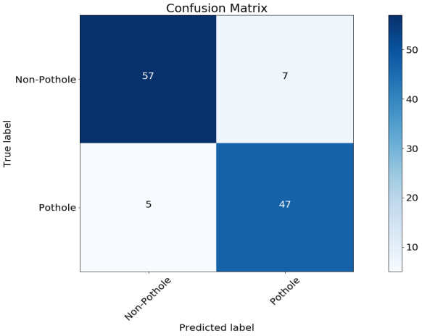

(b)

**Fig. 10. Results of InseptionResNetV2 Model**  (a) accuracy V/S epoch; (b) Confusion matrix.

Fig. 11 represents DenseNet201 model results. Fig. 11(a) shows model accuracy plot; Fig. 11(b) shows confusion matrix. With DenseNet201 model we achieved training accuracy of 98.89% and validation accuracy of 89.66 %.

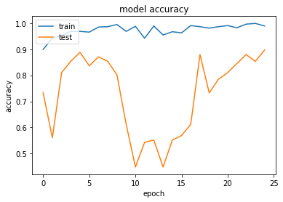

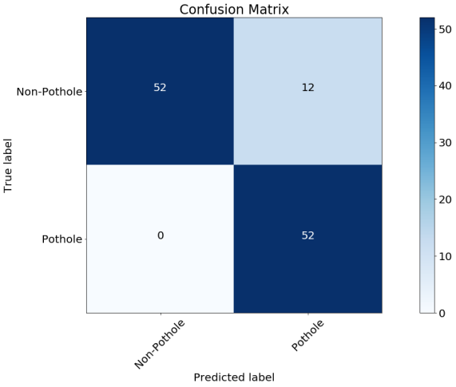

(b)

# Fig. 11. Results of DenseNet201 Model

(a) accuracy V/S epoch; (b) confusion matrix.

***D3.Results Comparison with CNN and pre-trained models:*** Table I presents the results of CNN model and pre-trained models in terms of training accuracy and validation accuracy.

**Table- I: Training and validation accuracy of all models.**

|  |  |  |  |
| --- | --- | --- | --- |
| **Model** | **Input size** | **Training accuracy (%)** | **Validation accuracy (%)** |
| CNN | 224 x 224 | 97.65 | 80.17 |
| ResNet50 | 224 x 224 | 100.00 | 85.34 |
| ResNet152 | 224 x 224 | 95.84 | 84.48 |
| ResNet50V2 | 224 x 224 | 99.31 | 82.76 |
| ResNet152V2 | 224 x 224 | 92.38 | 79.31 |
| AlexNet | 299 x 299 | 98.06 | 85.34 |
| LeNet | 299 x 299 | 99.58 | 89.66 |
| DenseNet201 | 224 x 224 | 98.89 | 89.66 |

The following Fig. 12. Shows the results graphically.

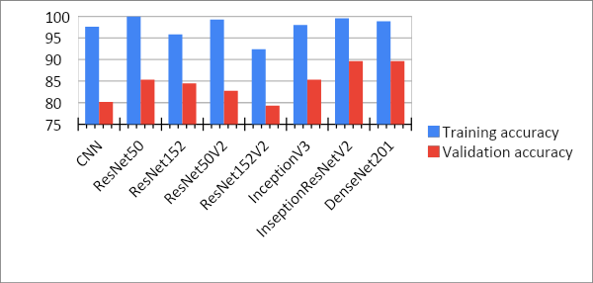

# Fig. 12. Accuracy using CNN and Pre-trained models

Table II presents the overall summary of the results in terms of validation accuracy, precision and recall.

|  |  |  |  |  |  |  |  |  |
| --- | --- | --- | --- | --- | --- | --- | --- | --- |
| |  |  |  |  |  |  |  |  | | --- | --- | --- | --- | --- | --- | --- | --- | | **Model Type** | **TP** | **FP** | **TN** | **FN** | **Test (Vali datio**  **n)Acc uracy (%)** | **Precisio n (%)** | **Recall (%)** |   **Table- II: Result Analysis for Pothole Detection**  (a) |

|  |  |  |  |  |  |  |  |
| --- | --- | --- | --- | --- | --- | --- | --- |
| CNN | 48 | 19 | 45 | 4 | 80.17 | 71.64 | 92.30 |
| ResNet50 | 43 | 8 | 56 | 9 | 85.34 | 84.31 | 82.69 |
| ResNet152 | 46 | 12 | 52 | 6 | 84.48 | 79.31 | 88.46 |
| ResNet50V2 | 52 | 20 | 44 | 0 | 82.76 | 72.22 | 1.0 |
| ResNet152V2 | 36 | 8 | 56 | 16 | 79.31 | 81.81 | 69.23 |
| InceptionV3 | 51 | 16 | 48 | 1 | 85.34 | 76.11 | 98.07 |
| InceptionResN etV2 | 47 | 7 | 57 | 5 | 89.66 | 87.03 | 90.38 |
| DenseNet201 | 52 | 12 | 52 | 0 | 89.66 | 81.25 | 1.0 |

Fig.13 shows training and validation accuracy using various Pre-trained models. The highest accuracy of 89.66% was achieved using InseptionResNetV2 and DenseNet201 pre-trained models. It was also found that ResNet50 and InceptionV3 has same accuracy of 85.34%.

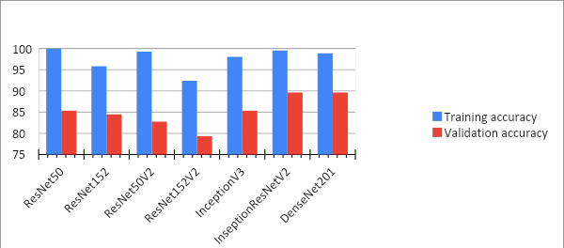

# Fig.13 Training and Validation Accuracy

Table III shows accuracy obtained for CNN and average accuracy obtained from ResNet50, ResNet152, ResNet50V2, ResNet152V2, InceptionV3, InceptionResNetV2 and DenseNet201pre trained models.

# Table- III: Comparison of training and testing accuracy obtained for CNN and average training and testing accuracy obtained for pre trained models

|  |  |  |  |  |
| --- | --- | --- | --- | --- |
| **Model** | **Accuracy** |  | **Average Accuracy** | |
| ***training*** | ***testing*** | ***training*** | ***testing*** |
| CNN | 97.65 | 80.17 | - | - |
| ResNet50,  ResNet152,  ResNet50V2,  LENET,  AlexNet | - | - | 99.44 | 87.5 |

Graphical results are shown in Fig. 14.

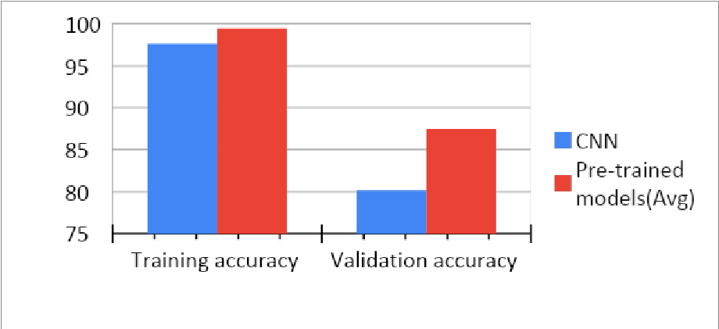

# Fig. 14. Average accuracy using pre-trained model V/S CNN model

It is observed that average accuracy of 87.5% is achieved using pre-trained model and using CNN model accuracy of 80.17% is achieved. With Lenet and AlexNet pre-trained models we achieved highest accuracy of 89.66%

# V. CONCLUSION

We have demonstrated and tested the pothole and non-pothole detection using various deep learning classifier algorithms. The performance of these models are measured and compared using various parameters like accuracy, precision, and recall. We achieved an accuracy of 89.66% by InseptionResNetV2 and DenseNet201 which is higher as compared to other models.

# V1. FUTURE WORK

Road Pothole prediction to connect with AI model. To automate this process by show the prediction result in web application or desktop application. To optimize the work to implement in Artificial Intelligence environment

# REFERENCES

1. J. S. Miller and W. Y. Bellinger, “Distress identification manual for the long-term pavement performance program,” FHWA-HRT-13-092 Revised May 2014, Federal Highway Administration,

[<https://www.fhwa.dot.gov/publications/research/infrastructure/pavem ents/ltpp/13092/13092.pdf>](https://www.fhwa.dot.gov/publications/research/infrastructure/pavements/ltpp/13092/13092.pdf)

1. C. Koch and I. Brilakis, Pothole detection in asphalt pavement images, Advanced Engineering Informatics, vol. 25, 2011, 507-515.
2. T. Kim and S. Ryu, “Review and analysis of pothole detection methods,” Journal of Emerging Trends in Computing and Information Sciences, vol. 5, 2014, no. 8, pp. 603–608.
3. H. Bello-Salau, A. M. Aibinu, E. N. Onwuka, J.J. Dukiya, and A. J. Onumanyi. "Image processing techniques for automated road defect detection: A survey", 11th International Conference on Electronics Computer and Computation (ICECCO), 2014.
4. Aparna, Yukti Bhatia, Rachna Rai, Varun Gupta, Naveen Aggarwal , Aparna Akula, “Convolutional neural networks based potholes detection using thermal Imaging”, Journal of King Saud University, 2019.
5. [Kwang Eun An](https://ieeexplore.ieee.org/author/37086187749) [, Sung Won Lee](https://ieeexplore.ieee.org/author/37086193083) [,Seung-Ki Ryu](https://ieeexplore.ieee.org/author/37086357507) [, Dongmahn Seo,](https://ieeexplore.ieee.org/author/37085433861) Detecting a pothole using deep convolutional neural network models for an adaptive shock observing in a vehicle driving, [IEEE International Conference on Consumer Electronics (ICCE),](https://ieeexplore.ieee.org/xpl/conhome/8322492/proceeding) 2018.
6. Hyunwoo Song, Kihoon Baek and Yungcheol Byun,Pothole Detection using Machine Learning, Advanced Science and Technology Letters, vol.150 (AST 2018), pp.151-155.
7. Lim Kuoy Suong and Kwon Jangwoo, Detection of Potholes Using Deep Convolutional Neural Network, Journal of Universal Computer Science, vol. 24, no. 9, 2018, 1244-1257.
8. Akagic, A., Buza, E., Omanovic, S., Pothole detection: an efficient vision based method using RGB color space image segmentation. In: Information and Communication Technology, Electronics and Microelectronics (MIPRO), 40th International Convention on (pp. 1104-1109) IEEE, 2017.
9. Ryu S.K., Kim T., Kim Y.R., Image-based pothole detection system for

ITS service and road management system. Math. Problems in Engineering, 2015.

1. J. Lin and Y. Liu, "Potholes detection based on SVM in the pavement distress image, " in Distributed Computing and Applications to Business Engineering and Science (DCABES), 2010 Ninth International Symposium on, 2010, pp. 544-547.